Flow 1: Front End UI working and returning results as per the uploaded document
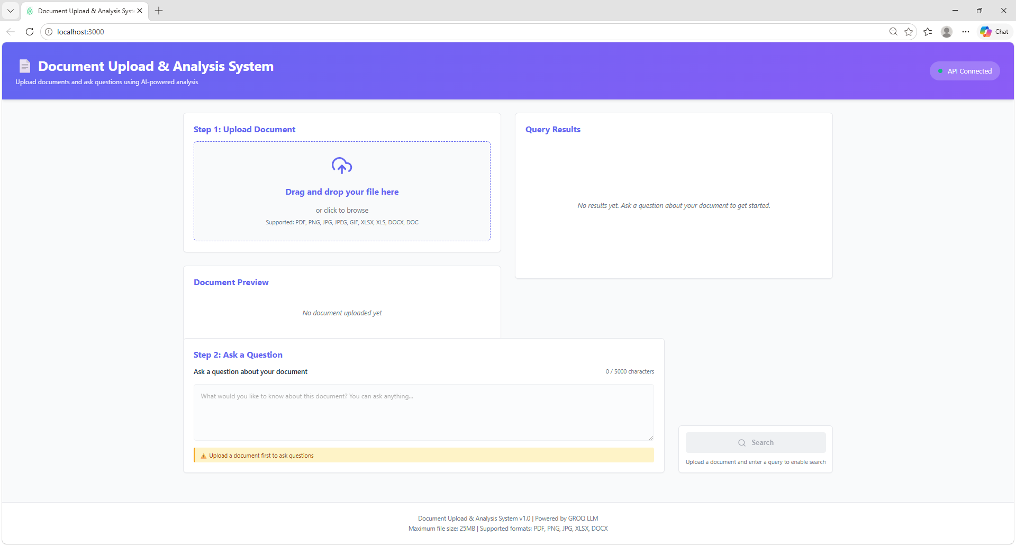
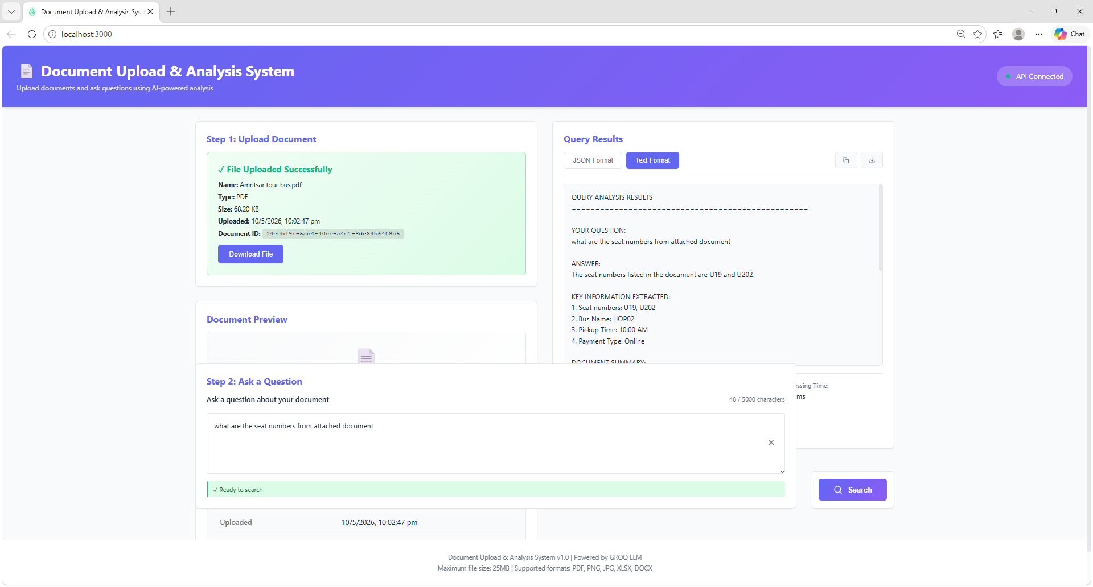

Flow 2: Re aligning the UI to make it more readable
Prompt:
Enhancements:
I want to make the below changes in front end UI application

Features to be removed:
- Remove the document preview feature- refer screenshot
- Removed the download document button at bottom of page- refer screenshot
- Remove the uploaded time at bottom of step 2- and just keep it in step-1 refer screenshot

Features to be added:
- Provide a clear button in Step-1
This feature should be enabled for the user to clear the attached document and re attach a new document
Each time when the user clicks clear button the attached document should be deleted
- Reduce the size of step-2 window - Ask a question and keep it aligned to Step 1 in Front End UI- REFER screenshot
- Put the search button exactly below step-2 window

Provide me list of files impacted and code changes required for the above changes
DO NOT make any changes without my approval
Highlight risks if any in making the above changes and how fast it can be reverted.

Post fixing the UI issues- New UI
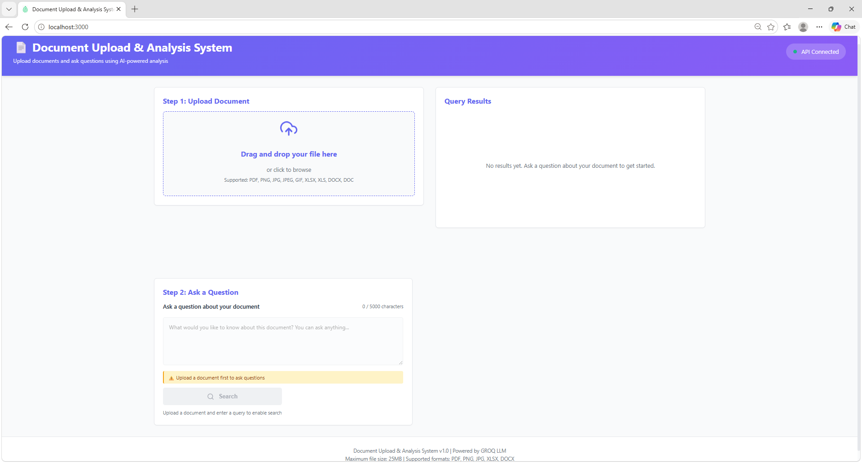
Clear button is only enabled when the document is uploaded and clicking on clear button deletes the contents in the page

Pdf document upload:

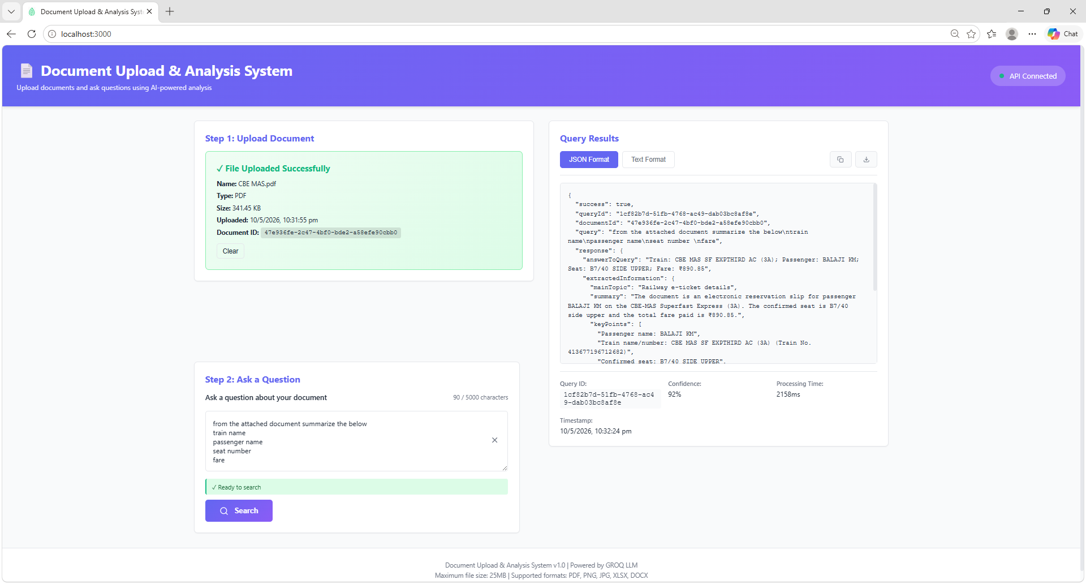

Text format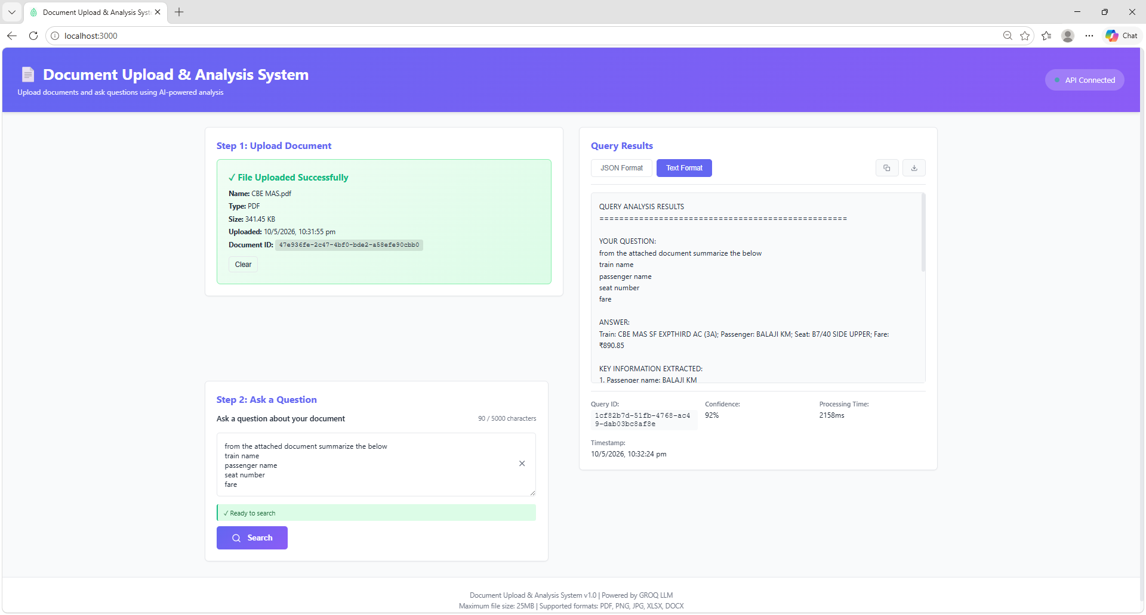
Json format
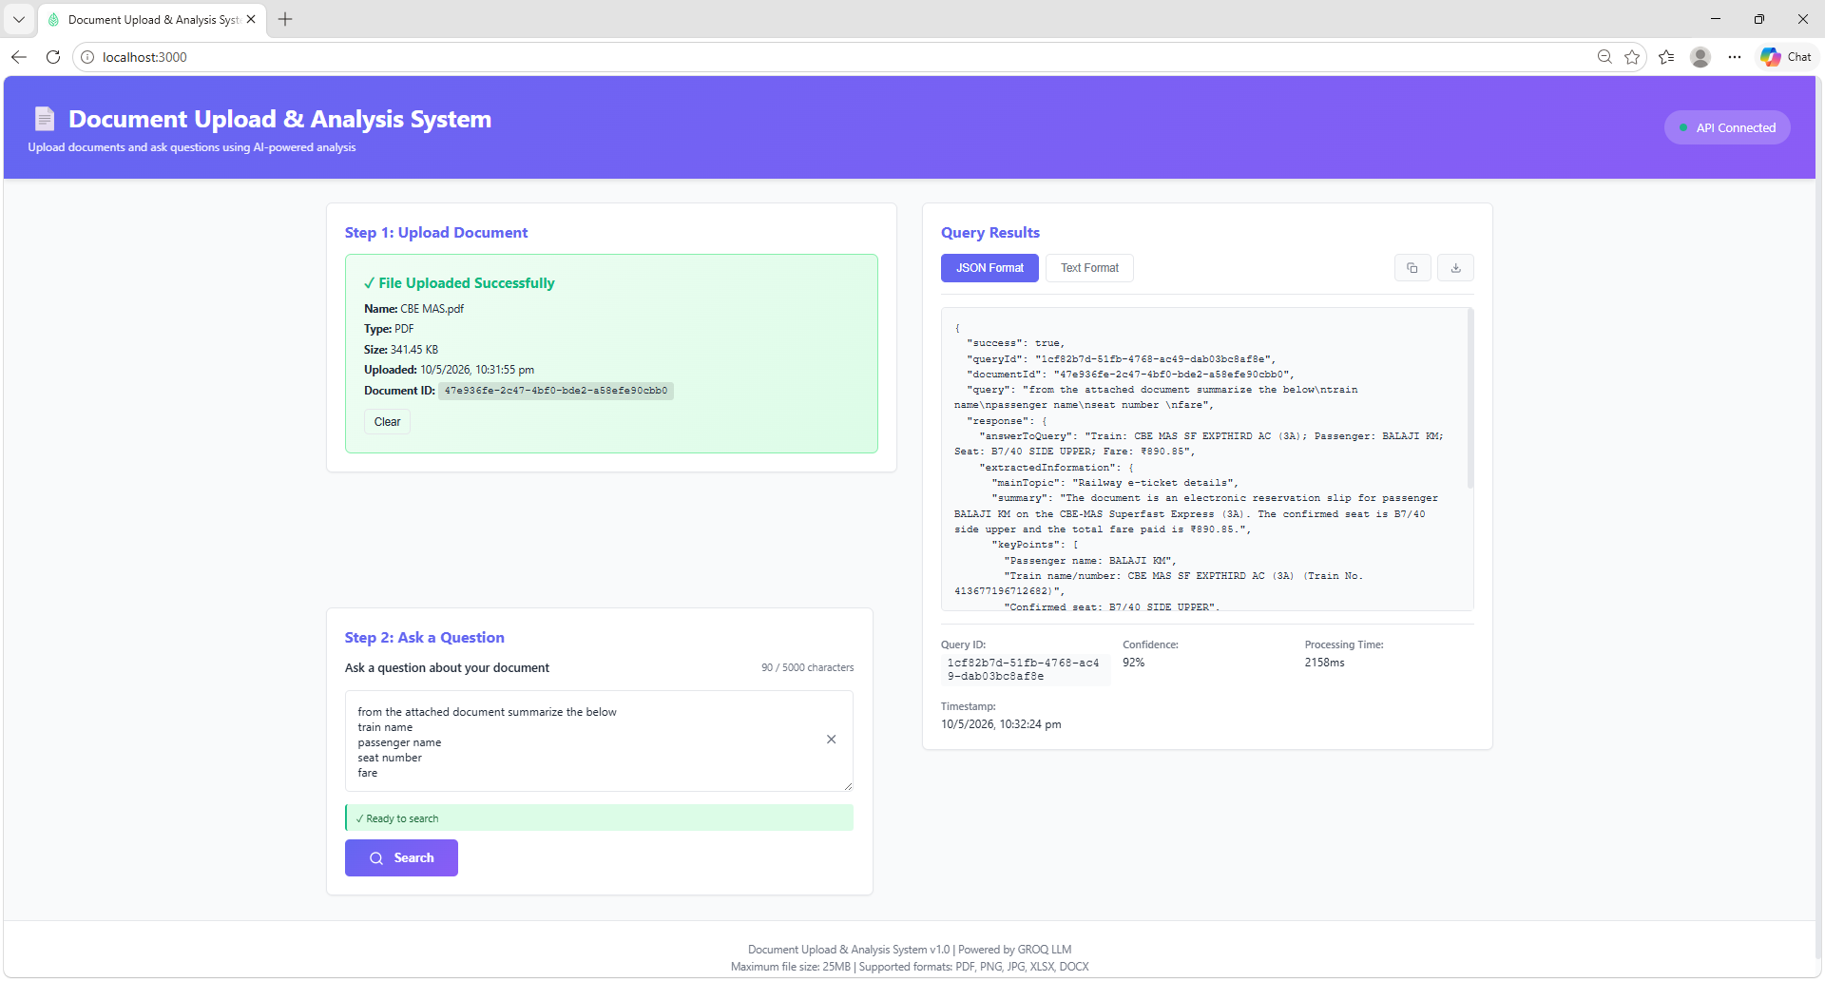

Word document upload:
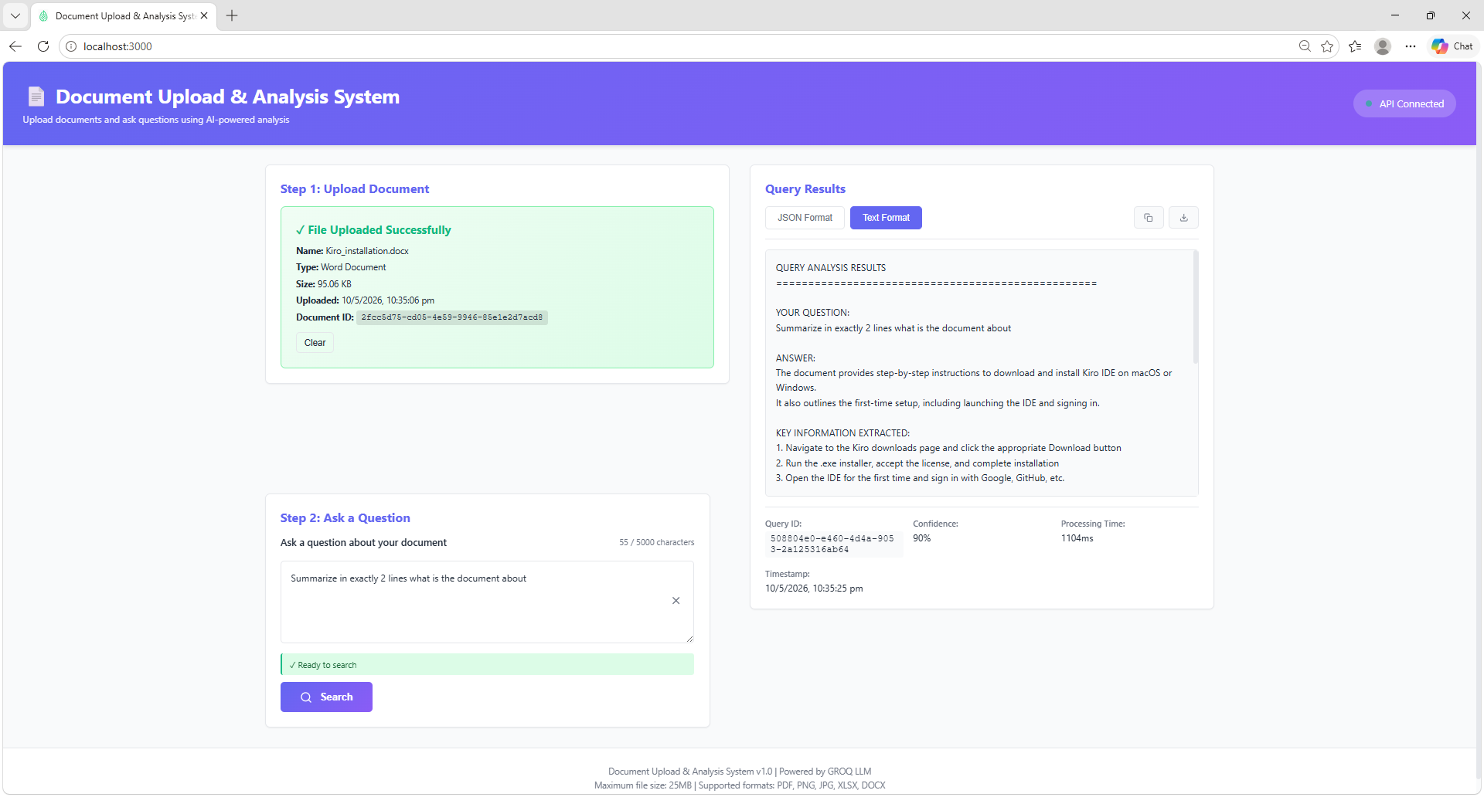
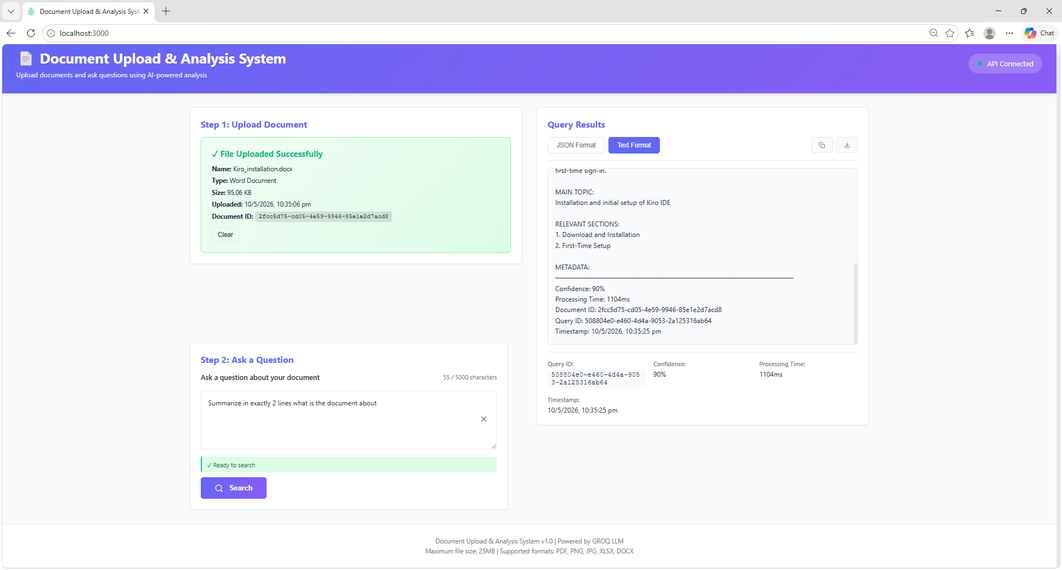

Excel upload:
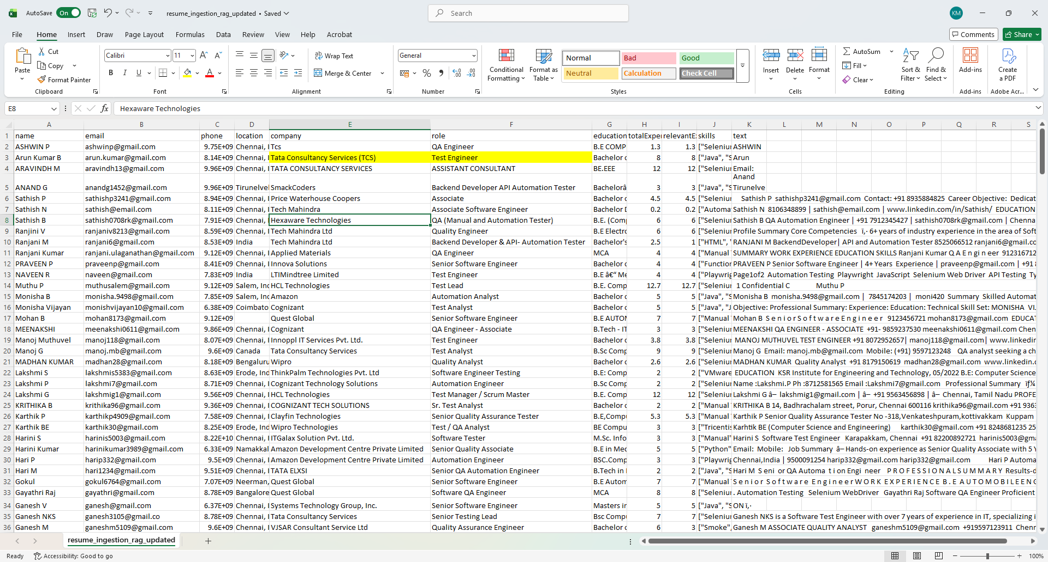
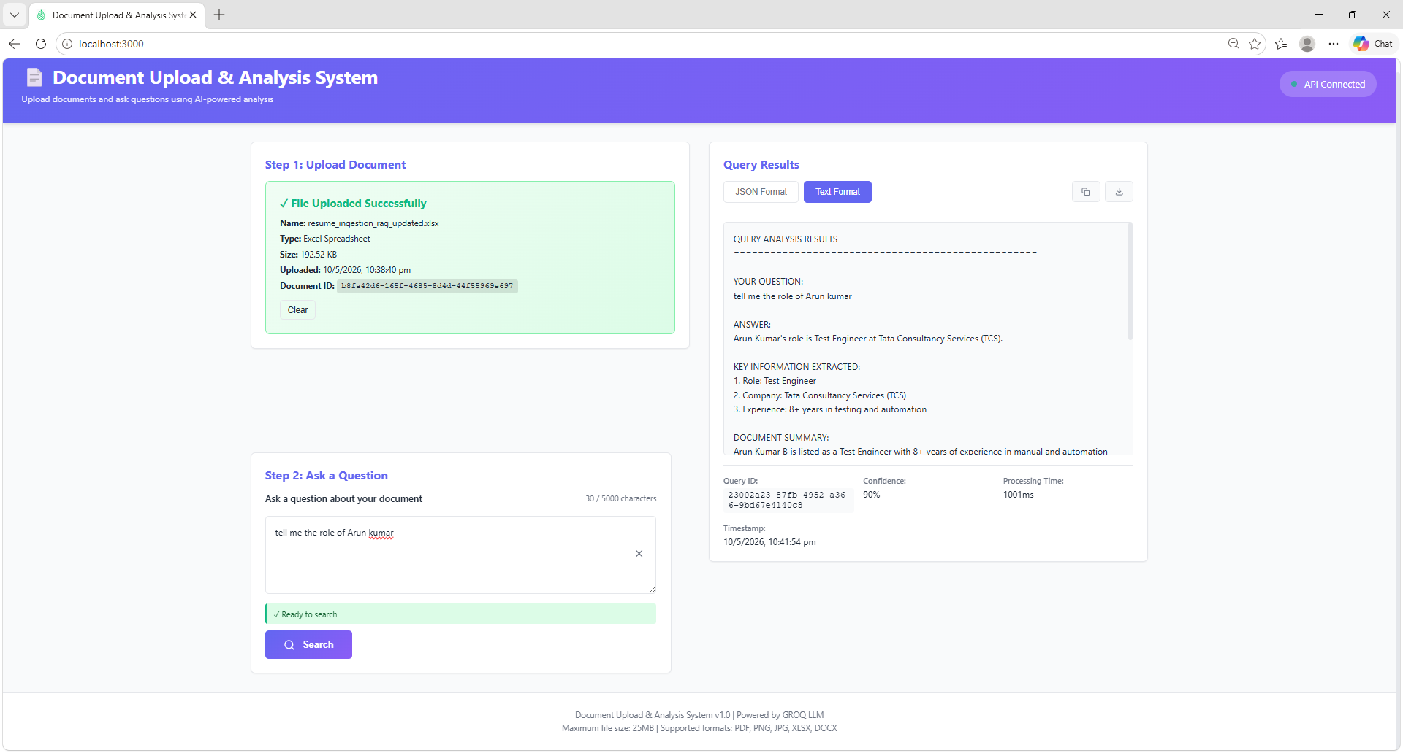

Playwright
3 agents setup
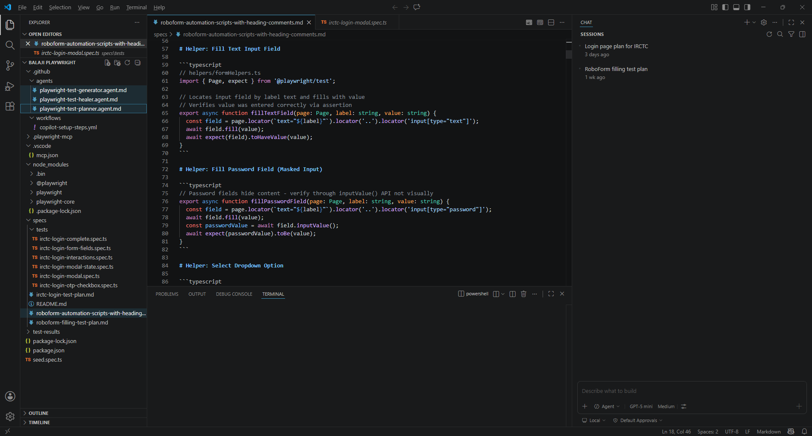

Robo form test plan md file

Robo form automation scripts
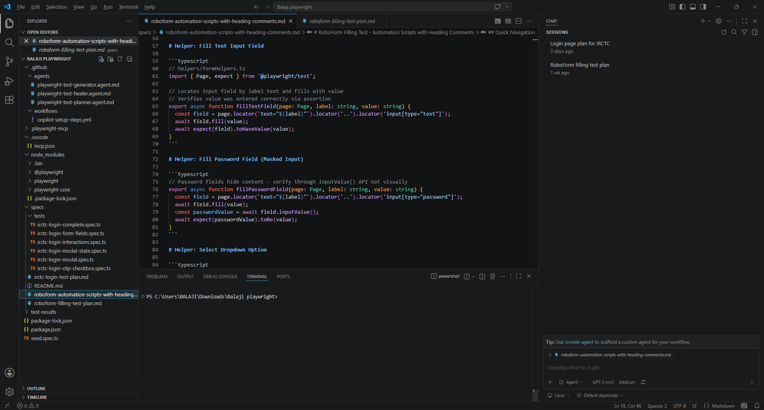

IRCTC test plan md file:
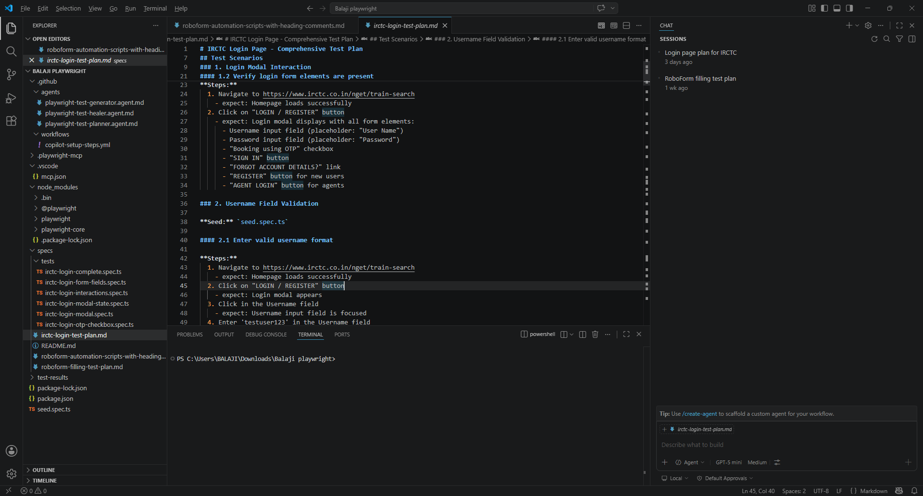
IRCTC automation scripts
